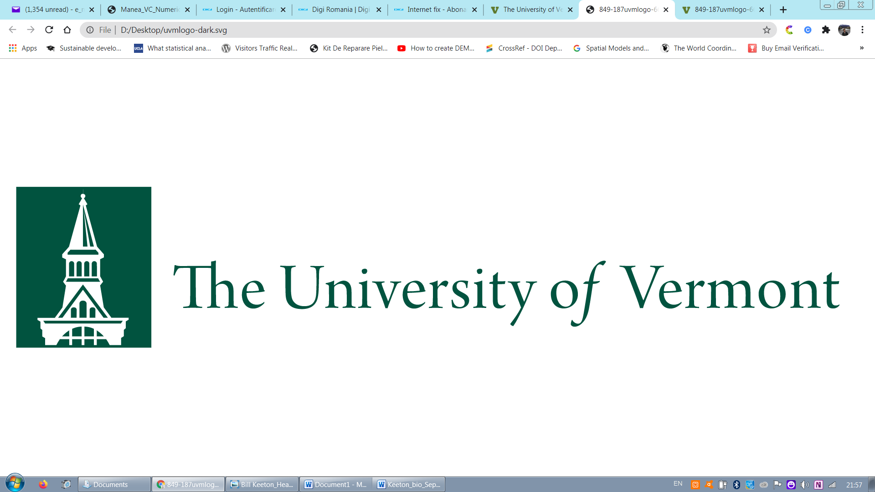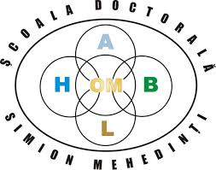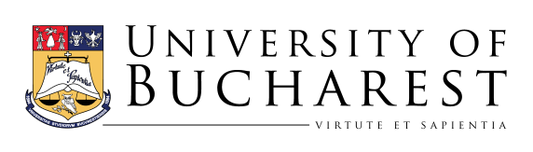

How to get published and influence the policy dialogue: effective writing, publishing, and communication in the environmental sciences
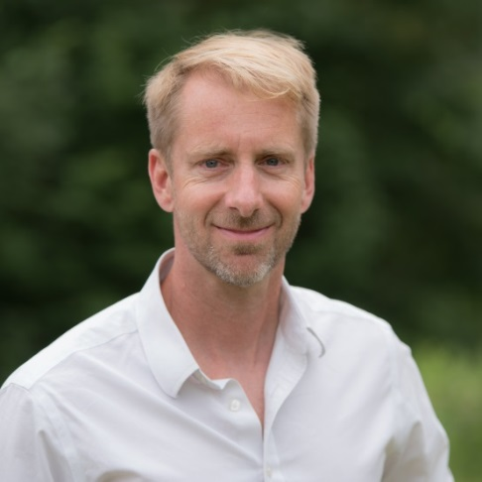

Speaker: Dr. William S. KEETON

Dr. Keeton is a Professor of Forest Ecology and Forestry at the University of Vermont, USA. There he directs the UVM Carbon Dynamics Laboratory and is a fellow in the Gund Institute for Environment. Dr. Keeton also chairs the IUFRO Working Group on Old-growth Forests and is a board member for Science for the Carpathians; he will serve as a Fulbright Scholar in Europe next year. Dr. Keeton holds a B.S. in Natural Resources from Cornell University (’90), a Masters in Conservation Biology and Policy from Yale University (’94), and a Ph.D. in Forest Ecology from the University of Washington (2000). His citation and publishing record are available on Google Scholar and ResearchGate.

Date: 29 October 2020, 16.00-18.00 hrs. + 30 min. Q&A session (EET+3)

Format: Online (Platform Google meet)

Presentation and discussions: English
This online seminar is targeted at early career scientists and doctoral students interested in building their credentials through rigorous publication and communication. Dr. Keeton will offer advice and tips based on his experience having authored or co-authored more than 130 peer-reviewed publications.The seminar will cover best practices for publishing in English language, international scientific journals. Dr. Keeton will review principles of effective science writing as well as ideas for successfully navigating the manuscript submission, review, and revision process.
Dr. Keeton has spent many years working at the interface of science and policy, both in the U.S. and in Europe. He is most interested in applying science to solving real-world problems. In the seminar, he will discuss the differing views of the role of scientists in the policy process, and present ideas for communicating science effectively to journalists, through popular media, through collaboration with NGOs, and to policy makers.
This is planned as an interactive seminar. Those attending will be asked to participate actively and come prepared having read background materials (to be determined). Critical thinking, dialogue, and discussion are welcomed.

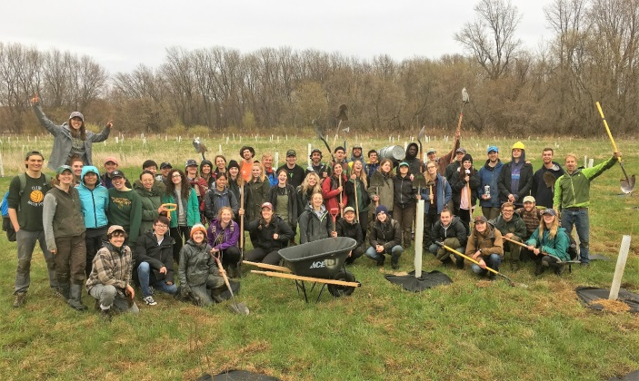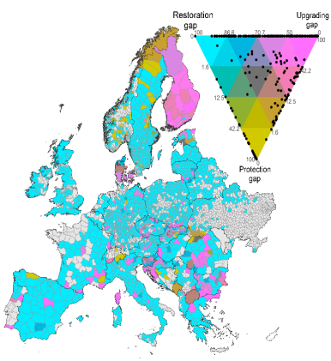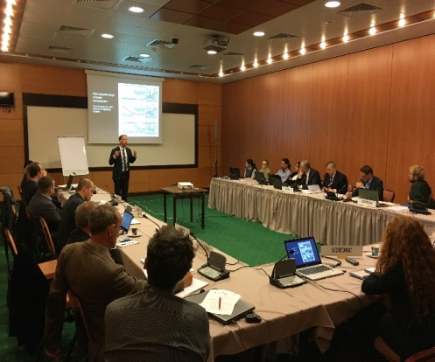

Dr. Keeton collaborates on large, multi-institutional papers, then applies that research through interaction with a wide range of policy forums. Addressing the Carpathian Convention. WG on Forests in Brasov, 2016.

Figure from Sabatini, Keeton, et al. 2020, Diversity and Distributions.

Working closely with a variety of community partners and NGOs, Dr. Keeton’s restoration ecology class has planted thousands of trees over the last two decades. This experience has taught him much about how to apply science through direct collaboration with stakeholders.

