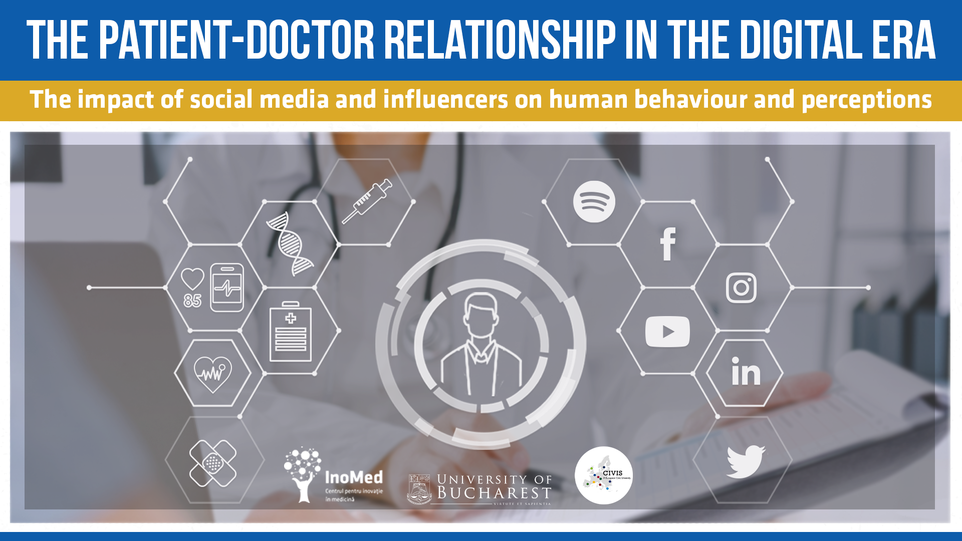
The patient-doctor relationship in the digital era. The impact of social media and influencers on human behaviour and perceptions

Events Timing: January - June 2022 (6 Webinars)
Events Address: Virtual
Contact us for more details or any questions you might have at adriana.boata@ino-med.ro

The Covid-19 pandemic highlighted the many disparities in human behaviour related to health and healthcare. On the one hand we have the infodemic and on the other hand, the role of online platforms is more important than ever in influencing individual behaviour - this health determinant impacts by no less than 36% our health.

All this background noise (because the patients are first of all citizens, persons) is reflected in the patient's relationship with the attending physician and on how the patient relates to the healthcare system and sees himself as part of it. Dr. Google phenomenon is a reality, as well as the Peoples’ Advocate, Facebook (specialized in matters of conspiracy theory) and the Cook&Fitness expert, Instagram, that promotes diets for all sorts of diseases or Professor TikTok. If used properly, these platforms can bring a lot of long-term benefits.

Over the coming years, innovations allowed spectacular and almost immediate transformations of society, but the pandemic has highlighted the many disparities in human behaviour related to health and healthcare.

If you are interested in this topic, we invite you to register for the six series webinar on “The patient-doctor relationship in the digital era. The impact of social media and influencers on human behaviour and perceptions” to better understand the relationship between patients-doctors-health system in the digital era, and how the social media and influencers impact human behaviour and perceptions.

Your level of health literacy will be briefly assessed after registration & acceptance and you will also be evaluated at the end of the webinar series (anonymous questionnaires).

Up to 20 students of the CIVIS Universities will automatically get the chance to attend the Summer School that ends the series: „Re-inventing the patient-doctor relationship in the digital age”, in Bucharest (22-26 of June). All they have to do is attend at least 5 of our webinars. The Summer School will feature lectures from key opinion leaders, workshops, debates and other communication activities on the subjects discussed during the Webinars. More details will come after being accepted.

By registering, you agree to actively attend at least 5 out of 6 webinars and to respond to the questionnaires. The data will only be used for research purposes.

#1 Meeting 27 Jan - Introduction: The medical innovations of the present
#2 Meeting 24 Feb - Health literacy: why it should be at the base of all health strategies
#3 Meeting 24 March - How social media influences human behaviour. And vice versa
#4 Meeting 28 Apr - The healthy influencers: the positive impact on human health
#5 Meeting 26 May - The evolution of the patient - doctor relationship through time
#6 Meeting 22 Jun - Conclusions: the adaptation of patient - doctor relationship to the digital context (The Summer School begins)

*Dates are subject to change according to administrative issues.

What’s next:

Jan 10 - 18 Registration
Jan 18 - 21 Selection of the participants
Jan 21 - Announcement of the selected participants

What you will need to provide upon registering:

- CV (that includes personal media channels/accounts);
- Letter of intent (Please include in your letter of intent the reason you want to participate in our project and 3 influencers or media channels that you use for health and care information).

- I agree on the anonymous use of my data (University, Influencers followed and the questionnaire answers) for research purposes.

Other details (not in the Google registration form)

Targeted audience - student or professor at any of the CIVIS Universities with an interest towards the medical system.

