Project: Service-Learning: Intersectoral Collaboration Practices for the development of students’ soft skills and socially engaged universities
WP 4 - Toward the implementation of SL practices in each university

INSPIRED SERVICE LEARNING PROJECTS
First Local Event at the University of Bucharest
October 31, 2023
Project 1 : SDG Awareness and Behavioural Changes. Case of Sustainable Consumption Acronym: SDG-ABC
Main objective: to increase awareness on SDGs, particularly towards sustainable consumption and to implement adequate actions in this manner.

Project 2 : Therapeutic Garden: The Green Outing Experience
The purpose of the project is to enhance experiential learning, real life social interaction and communication, and to nurture well-being of students and tutors altogether.

Project 3 : Support services for the assessment of students with special educational needs
Main objectives: increasing the quality of the initial training of specialists in special psychopedagogy by including the service learning approach in the mandatory study program; increasing the quality of inclusion of children with special educational needs in the educational environment of the schools included in the target group; improving teachers' skills regarding inclusion and psycho-pedagogical reflection by applying tools specific to universal design for learning and rewilding education.

Project 4 : Chemistry Goes Outdoors
The goal of this service-learning project is to provide a service to children, secondary school, and high school pupils, simultaneously allowing the involved MSc students to acquire specific and transversal competences.

Project 5 : Reading Caravan
The project has the following objectives: to increase the level of reading by providing new books to children from rural areas, to test the reading skills of the students through the app and reward the students who read books by the score they achieve on the platform.

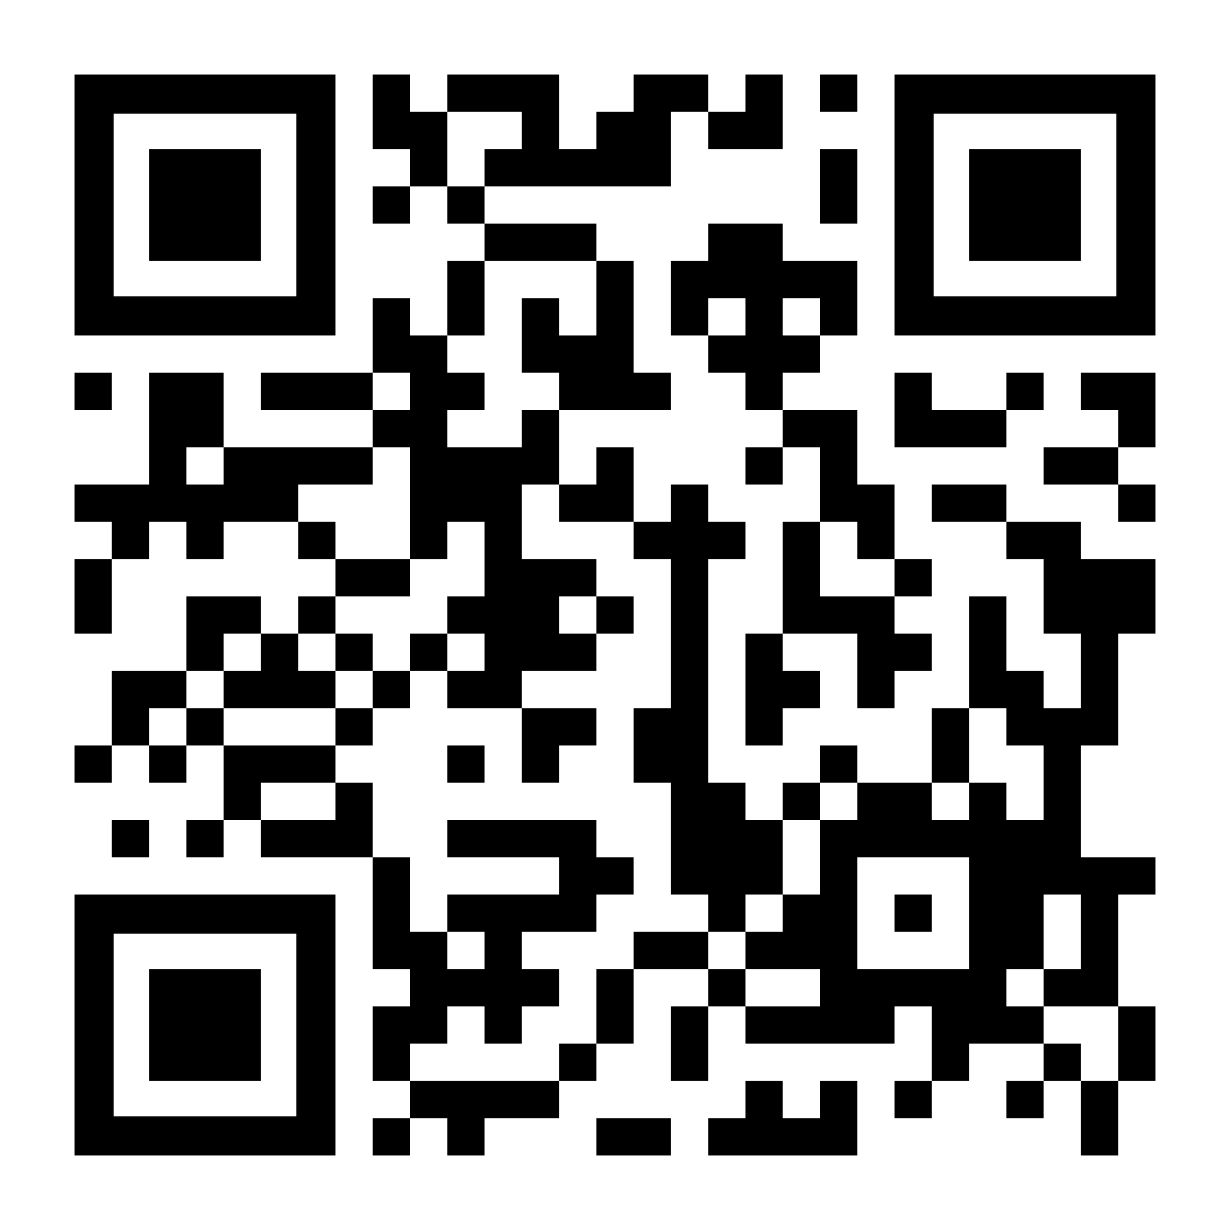
For final survey, at the end, please access:

