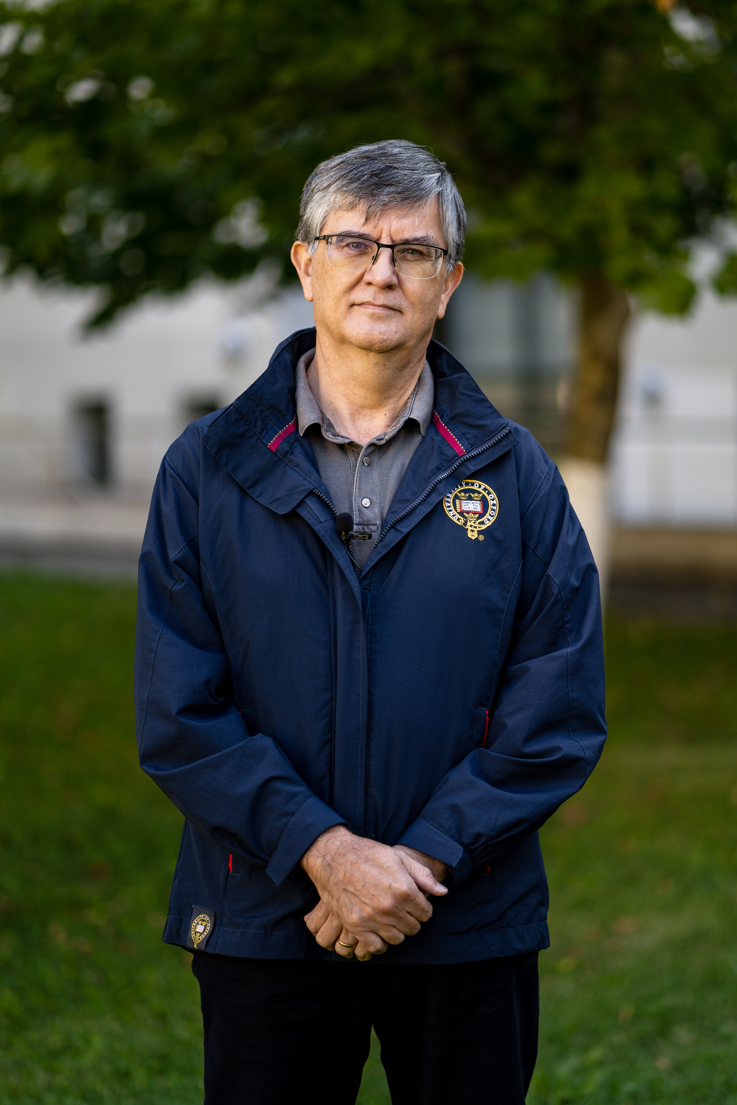Dr. Mircea Dumitru is a Professor of Philosophy at the University of Bucharest (since 2004). Vice-president of the Romanian Academy since 2022. Executive Director of Romanian-US Fulbright Commission (since 2020). Rector of the University of Bucharest (2011-2019). President of the European Society of Analytic Philosophy (2011 - 2014). President of the International Institute of Philosophy (2017 - 2021). Fellow of Academia Europaea (since 2019), Corresponding Fellow of the Romanian Academy (2014-2021). Fellow of the Romanian Academy (since 2021). Minister of Education and Scientific Research (July 2016 - January 2017). Visiting Professor at Beijing Normal University (2017 - 2022). President of Balkan Universities Association (2019 - 2022).
He holds a PhD in Philosophy at Tulane University, New Orleans, USA (1998) with a topic in modal logic and philosophy of mathematics, and another PhD in Philosophy at the University of Bucharest (1998) with a topic in philosophy of language.
Invited Professor at Tulsa University (USA), CUNY (USA), NYU (USA), Lyon 3, ENS Lyon, University of Helsinki, Pekin University (Beijing, China), Renmin University (Beijing, China), CUPL (Beijing, China), Xi’an University (Xi’an, China). Main area of research: philosophical logic, metaphysics, and philosophy of language.
Main publications: Modality and Incompleteness (UMI, Ann Arbor, 1998); Modalitate si incompletitudine, (Paideia Publishing House, 2001, in Romanian; the book received the Mircea Florian Prize of the Romanian Academy); Logic and Philosophical Explorations (Humanitas, Bucharest, 2004, in Romanian); Words, Theories, and Things. Quine in Focus (ed.) (Pelican, 2009); Truth (ed.) (Bucharest University Publishing House, 2013); article on the Philosophy of Kit Fine, in The Cambridge Dictionary of Philosophy, the Third Edition, Robert Audi (ed.) (Cambridge University Press, 2015), Worlds of Thought (in Romanian, Lumi ale gândirii, Polirom Publishing House, 2019), Metaphysics, Modality, and Meaning. Themes from the Work of Kit Fine (ed.) (Oxford University Press, 2020). Thinking It Through. Selected Papers of Kit Fine (Oxford University Press, work in progress), Modality and Incompleteness. An Account through Correspondence Theory (Springer, work in progress).

